Probability Lab 2

Question 1

Code

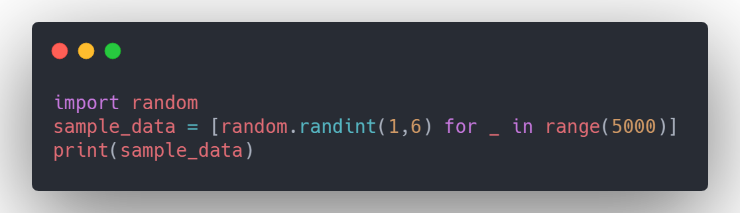

Output

Snippet

[3, 1, 1, 4, 6, 4, 2, 5, 1, 4, 4, 4, 3, 1, 3, 1, 2, 5, 3, 4, 2, 6, 2, 3, 4, 3, 5, 1, 2, 4, 4, 2, 6, 5, 3, 6, 1, 2, 4, 4, 4, 1, 5, 6, 4, 6, 3, 3, 5, 2, 1, 5, 5, 1, 2, 4, 5, 6, 5, 2, 3, 2, 4, 5, 4, 3, 4, 6, 5, 2, 3, 3, 4, 1, 5, 4, 6, 3, 1, 3, 6, 1, 6, 2, 5, 1, 3, 2, 6, 6, 4, 4, 2, 4, 6, 1, 3, 2, 5, 1]

Question 2

Code

Output

Snippet

[[5, 3, 1, 5, 4, 6, 2, 1, 2, 4, 1, 5, 1, 6, 5, 5, 1, 1, 5, 4, 5, 5, 6, 4, 2, 1, 2, 2, 4, 6, 3, 5, 6, 4, 4, 1, 3, 4, 3, 4, 1, 2, 6, 2, 6, 5, 3, 3, 2, 5, 5, 3, 1, 2, 3, 6, 6, 1, 5, 5, 2, 6, 2, 2, 5, 5, 2, 3, 1, 2, 5, 5, 2, 2, 3, 2, 3, 6, 1, 3, 1, 3, 5, 3, 3, 2, 1, 4, 2, 1, 2, 5, 4, 4, 5, 2, 3, 6, 6, 6, 3, 6, 2, 2, 6, 1, 4, 3, 4, 5, 1, 2, 6, 4, 1, 1, 5, 3,

Question 3

Code

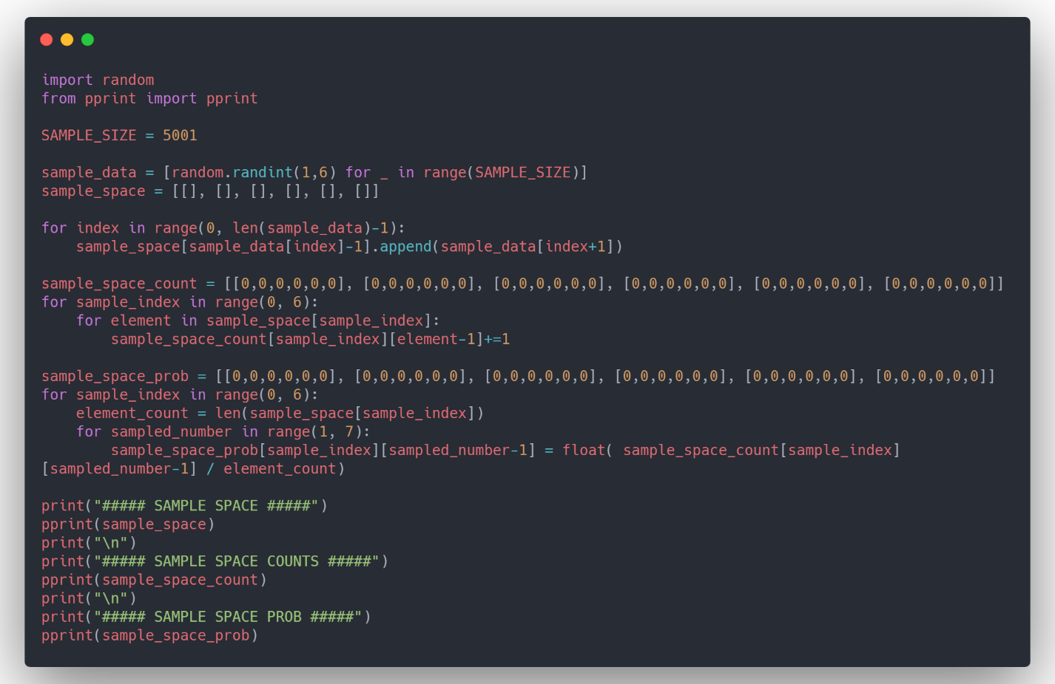

Output

##### SAMPLE SPACE COUNTS #####

[[188, 136, 145, 146, 137, 144],

[141, 151, 129, 134, 136, 132],

[143, 135, 142, 135, 135, 119],

[164, 141, 134, 123, 134, 153],

[123, 136, 134, 173, 111, 141],

[137, 125, 125, 138, 164, 116]]

##### SAMPLE SPACE PROB #####

[[0.20982142857142858,

0.15178571428571427,

0.16183035714285715,

0.16294642857142858,

Question 4

Code

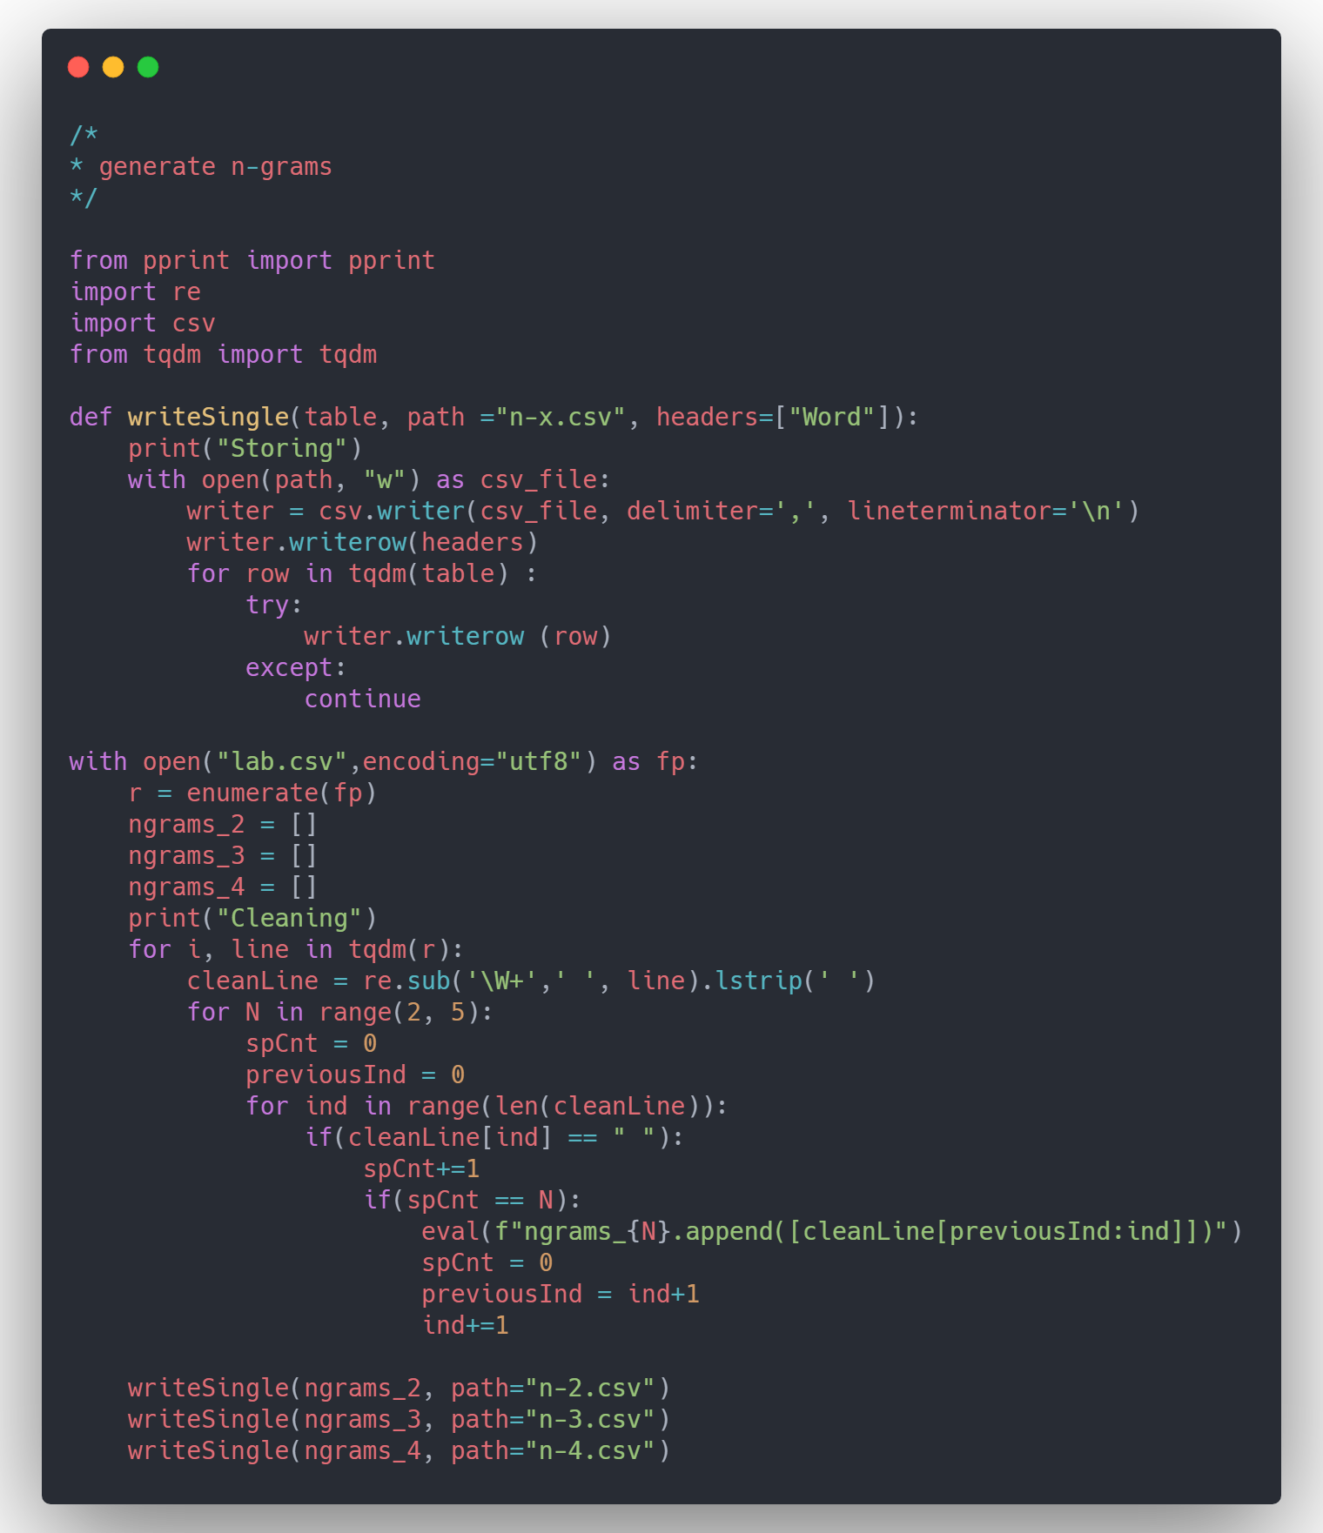

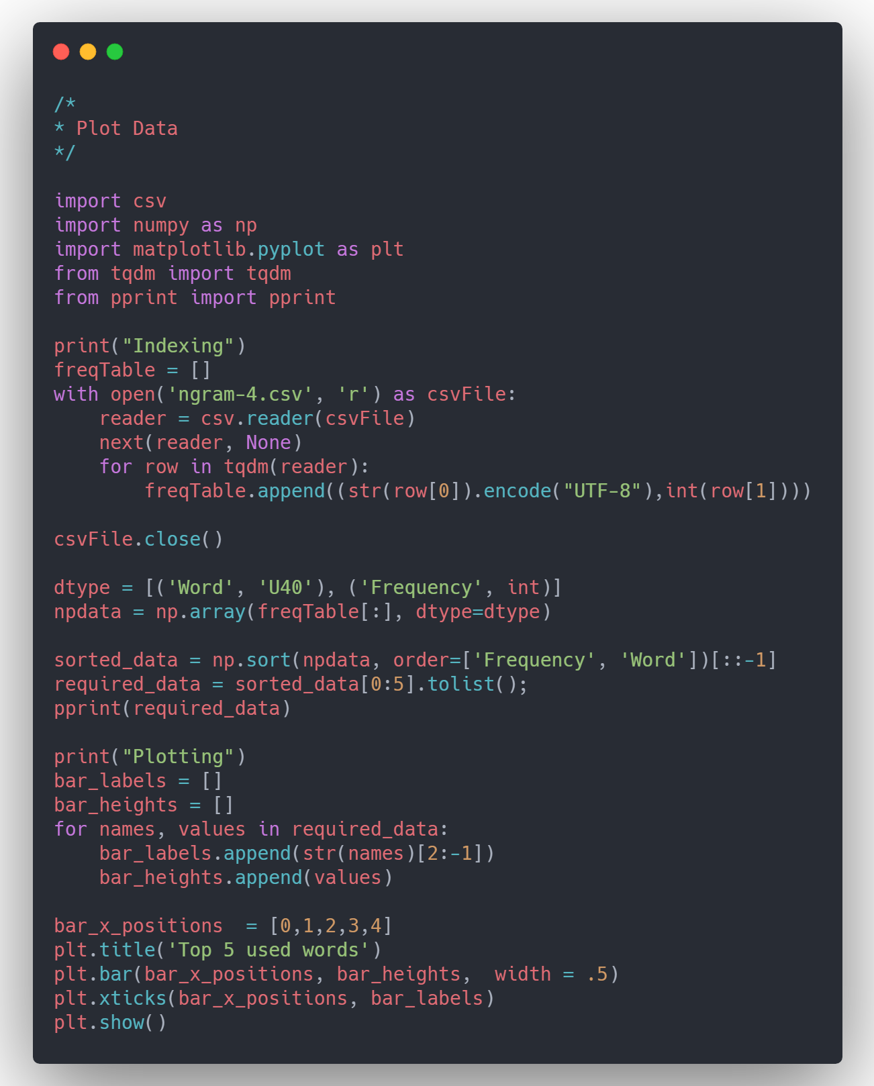

Output

